**New England Fancy Guppy Association**

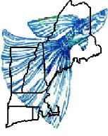presents an

**International Fancy Guppy Assoc.**

Sanctioned

**Fancy Guppy Show**

June 13 & 14, 2020

[**www.newenglandguppies.org**](http://www.newenglandguppies.org/)

Come and see some of the best guppies in the world!!!

**Where: Dr.** Franklin Perkins School, Janeway Building, 971 Main St., Lancaster, MA 01523

**Why:** Come to the auction to buy great quality breeding stock!

**More Info:** E.T. Mellor, 11 Morgan Circle, Amherst MA 01002, 413-549-0478

Greg Billings, 10 Sky Farm Lane, Sterling MA 01564, 978-870-2593

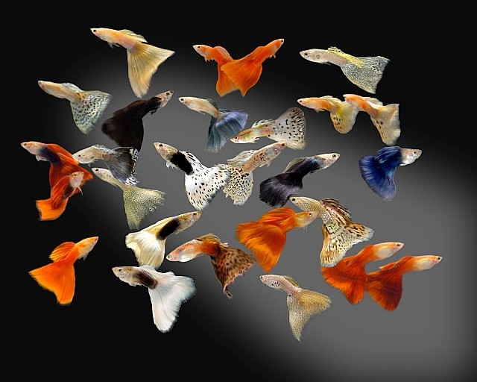**Schedule**

**Saturday, June 13, 2020**

Registration of all fish: 9 AM – 2:30 PM Judging - 3 PM until done

(Public may silently observe judging) Show room open until 9 PM for visitors

**Sunday, June 14,2020**

Open to the Public: 9 AM – 12 Noon

**Auction** (open to the public): 10 AM

(Come at 9:00AM to start viewing auction fish)

Visit our web site for more info: [www.newenglandguppies.org](http://www.newenglandguppies.org/)

Come join us and consider becoming a member of the New England Fancy Guppy Association.

**This is what new members can look forward to….**

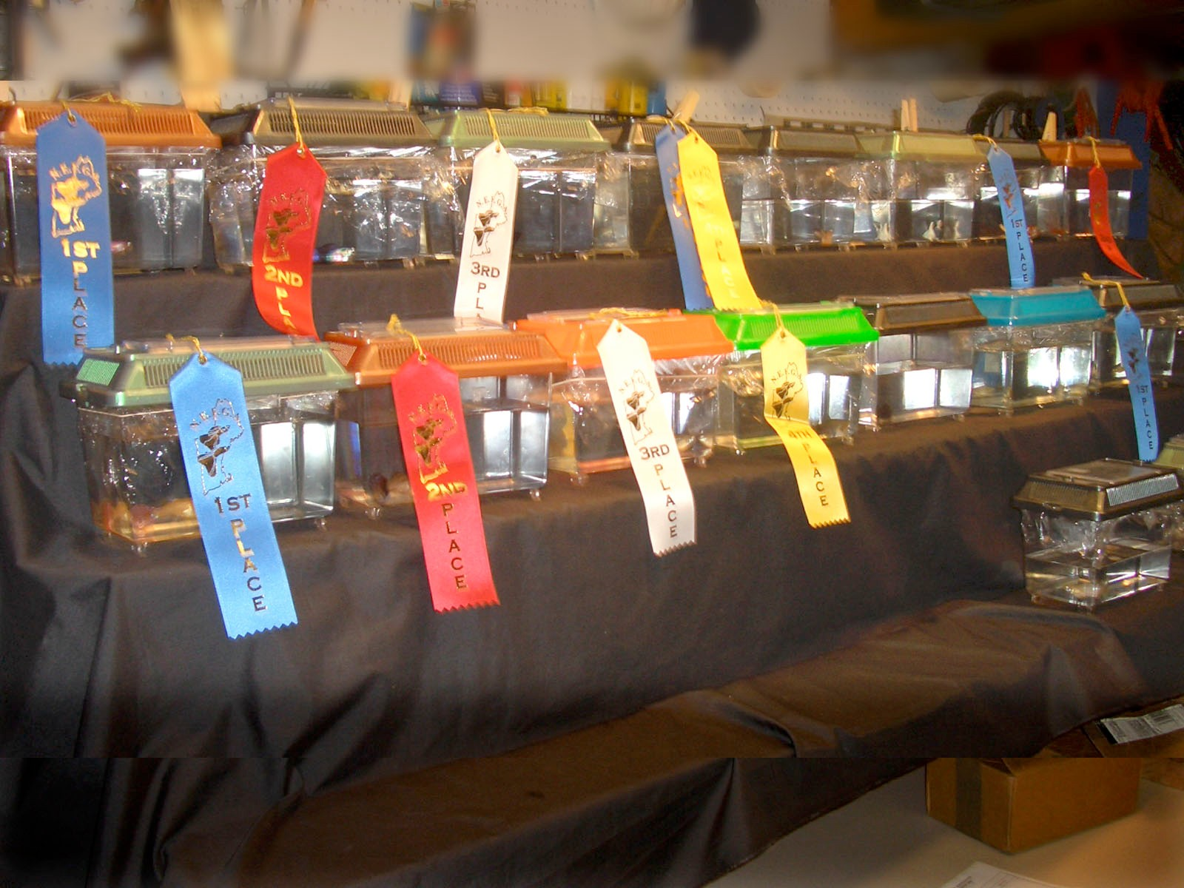 “monthly” meetings at homes with very different fish room setups interesting and informative monthly member requested seminars club purchasing power and savings of common needed supplies "Fish for Kids" project promoting the hobby in schools

collectively having hundreds of years of experience raising guppies

common sharing of breeding stock among members

electronic copy of PAST year’s "Guppy Gazettes

team work of putting on an IFGA sanctioned show each year

monthly bowl shows

special breeding projects

detailed collection in our club loan library

NEFGA "coffee table" picture book

IFGA “Guppy Abstracts” in loan Library