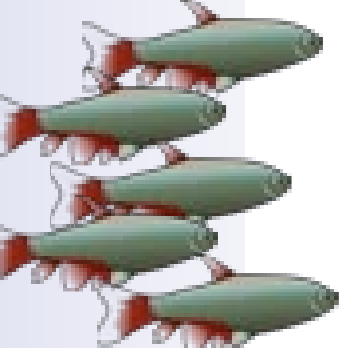

NORWALK AQUARIUM SOCIETY WHERE FRIENDS AND FISH MEET
55th Annual Tropical Fish &
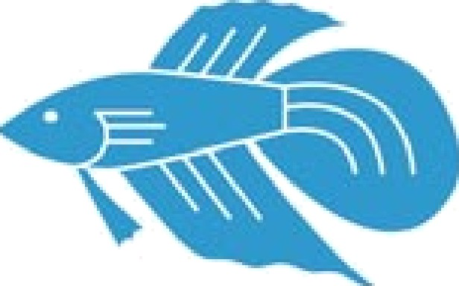
Aquarium Equipment Auction
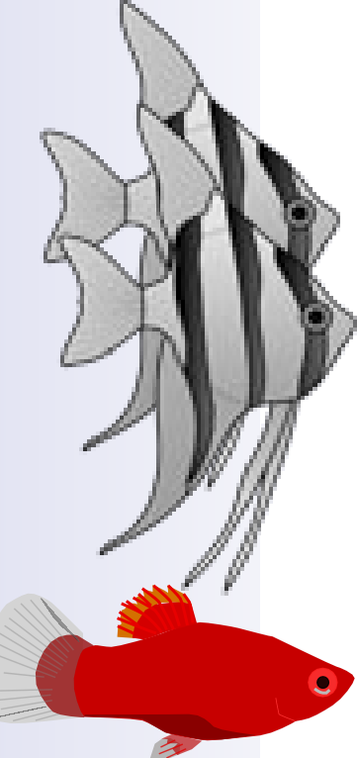
One of the Northeast's Largest Auctions of Beautiful Tropical Fish, New & Good Used Aquarium Equipment!

NEW LOCATION
Where Westport VFW
465 Riverside AVE, Westport CT
please park in the back and use back door

When Sunday, October 2, 2022
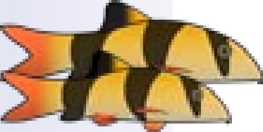
Registration/Viewing: 9:00-11:00 a.m. Auction Starts at 11:30 p.m.
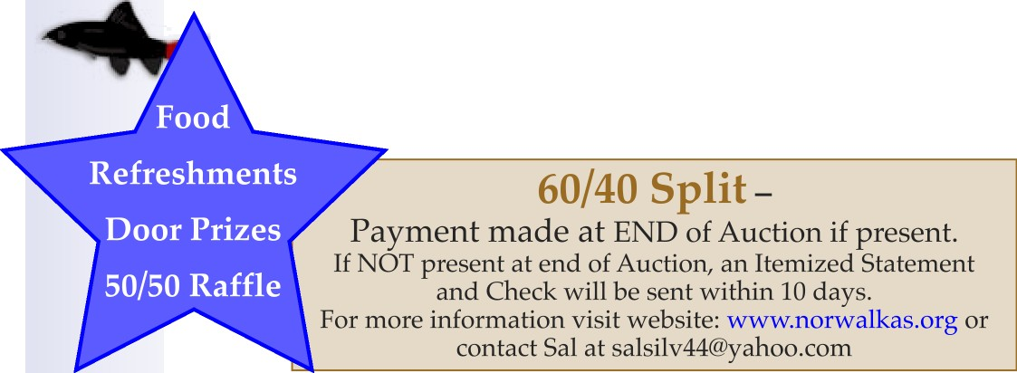
Auction is open to the Public
Free Bidder Cards. Lot Bumps $2
download auction registration form at WWW.norwaIkas.org

